

Healthy Living Messaging for Your Communication Channels

Share tools, resources, and healthy recipes and articles with your employees and members of your community. General messaging and links for newsletters:

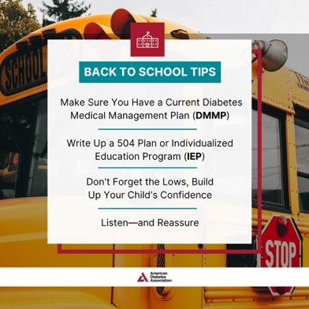

(August) National Back to School Month
Heading back to school with diabetes? 📚 Ensure your child thrives this school year with these essential tips from the American Diabetes Association®. Discover more resources at diabetes.org/SafeAtSchool. 🍎#SafeAtSchool

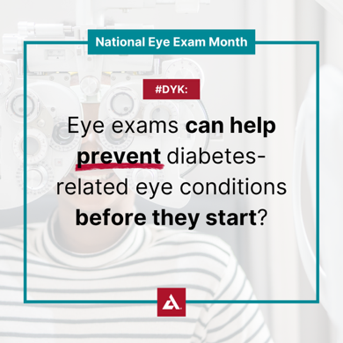

(August) National Eye Exam Month
This #NationalEyeExamMonth, let's focus on #eyehealth and stay ahead of complications. Take action for healthy vision by taking the pledge to get an eye exam today at diabetes.org/EyePledge. 📝👁️



(August) The ADA’s 85th Anniversary Month
2025 marks the 85th year of the American Diabetes Association® (ADA), the nation’s leading voluntary health organization touching the lives of millions with the mission to prevent and cure diabetes and to improve the lives of all people affected by diabetes. To help the 85 years of momentum going, become an ADA volunteer at diabetes.org/Volunteer. #WeFight

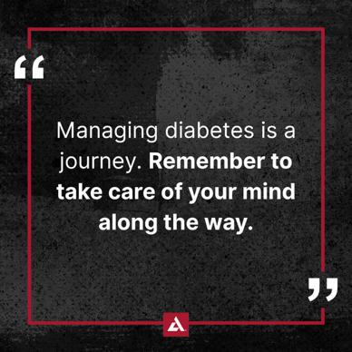

(September) Mental Health - National Suicide Prevention Month
Let's not forget that managing diabetes is a journey with both our bodies and minds. Use the American Diabetes Association®’s newly updated Mental Health Professional Directory to find a professional near you who can offer the support you need at bit.ly/3E7JGKF. #MentalHealthMatters

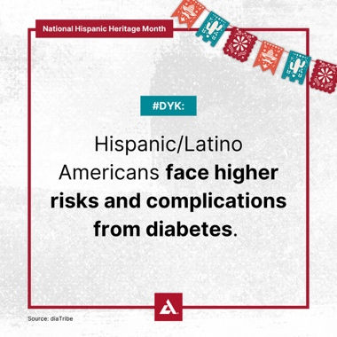
(September 15 – October 15) Hispanic Heritage Month
Given the increased prevalence of type 2 diabetes among Hispanic/Latino Americans, the impact of diabetes-related complications is also greater. Therefore, it's crucial to understand your risk of developing type 2 diabetes and learn how to reduce it. Discover more about your risk by taking the American Diabetes Association®’s free 60-second risk test at diabetes.org/RiskTest. #HispanicHeritageMonth


(November) American Diabetes Month®
🚨 Over 38 million Americans are living with diabetes. We're on a mission to end this epidemic, but we need your help! Join us and the American Diabetes Association® in the fight to end diabetes this #AmericanDiabetesMonth by getting involved at diabetes.org/GetInvolved. #WeFight


Ask the Experts
#ICYMI: Catch up on the American Diabetes Association®’s Ask the Experts events, focusing on obesity care conversations, available treatments, and more. View the recordings at bit.ly/44jPVWG.

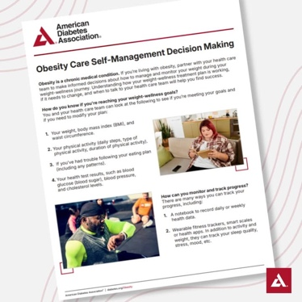

Obesity
If you're facing challenges with obesity, consulting your doctor is a crucial step in creating a personalized treatment plan. The American Diabetes Association® has developed a new resource, the Obesity Care Self-Management Decision Making guide, to empower you with the tools and information you need to better manage your health. Check it out at bit.ly/4i5Yis0.

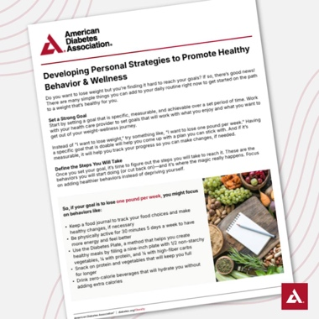
Obesity
Take the first step on the path to a weight that’s healthy for you. Learn new ideas from the American Diabetes Association®’s resource guide for developing daily behaviors and strategies that will help you reach your health goals. Download it now at bit.ly/4i5Yis0.

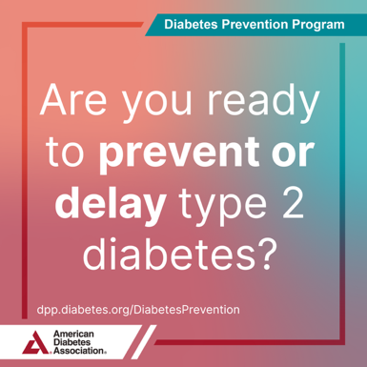
DPP Learning your diabetes risk is the first step in taking action to prevent it. Find out your risk through the Type 2 Diabetes Risk Test and receive actionable next steps in your health journey at dpp.diabetes.org/DiabetesPrevention. #PreventDiabetes #DiabetesPreventionProgram

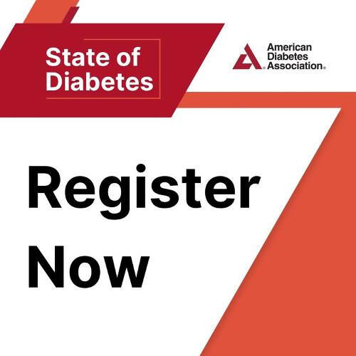

State of Diabetes
Join us for this year's American Diabetes Association®’s State of Diabetes events! These events unite influential figures and brings together employers, industry leaders, health care professionals, payers, and community members to address the contemporary landscape of diabetes and obesity. Find an event near you this November and register now at bit.ly/3Lw7eJe! #StateOfDiabetes #WeFight

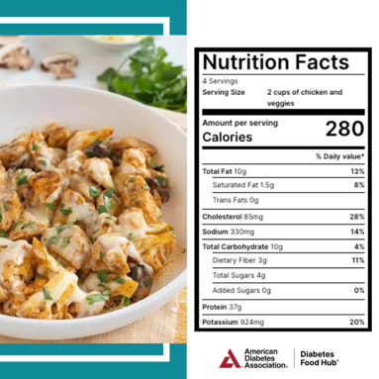
Recipes This delicious cauliflower skillet will be a new family favorite. A creamy sauce packed with low-carb veggies and protein delivers high taste and nutrition! View the full recipe from the American Diabetes Association® at bit.ly/45XEvIN.



Recipes
A unique Asian fusion recipe, this soup is a flavorful and hearty combination of tender turkey meatballs, fresh vegetables, and aromatic herbs. Keep your meal low carb by adding a side of non-starchy vegetables. View the full recipe from the American Diabetes Association® at bit.ly/3AT6KLL.


Travel Tips
☀️ ✈️ Make your getaway smooth with expert tips from the American Diabetes Association® for flying with diabetes. From TSA-friendly packing strategies to must-have supplies, we’ve got everything you need to travel confidently. Learn more at bit.ly/4f7ER0I. 🧳


Advocacy
Let's stand together to advocate for diabetes research and programs, health care, insulin affordability, and diabetes prevention and help support people living with and impacted by diabetes everyday—until we find a cure. 🌟 Become a Diabetes Advocate today at bit.ly/4bvvLte. 💪💙


(Now through October) Tour de Cure®
136 million Americans are living with diabetes or prediabetes. Chances are, we all know someone who’s been impacted. When you participate in a Tour de Cure® event, you’re not just pedaling, you’re supporting all those who are affected and joining the fight to end diabetes for good! 🚴‍♂️ Find your local ride at diabetes.org/Tour. #ADATour2025


(Now though November) Step Out® Walk
Lace up your shoes and let’s hit the pavement together! Participate in a Step Out® Walk event near you this year. By participating, you’ll help increase awareness and support diabetes prevention and management. Every step matters. Find your local walk at diabetes.org/StepOut. 🚶‍♂💪 #ADAStepOut2025

