Healthy Living for Your Communication Channels

Share tools, resources, and healthy recipes and articles with your employees and members of your community. General messages and images are included.

September
This #SuicidePreventionMonth, remember that you’re not alone—especially if you’re managing diabetes. Find specialized support near you with the American Diabetes Association®’s Mental Health Professional Directory at diabetes.org/MentalHealth. If you need help right now, call 988 anytime.
Suggested Visual:
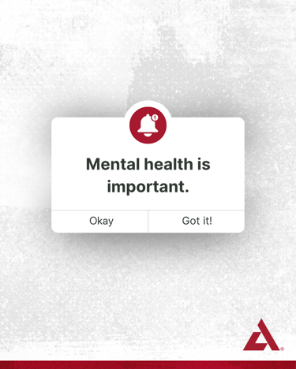

Hispanic Heritage Month: September 15-October 15, 2026
This #HispanicHeritageMonth, we celebrate the strength of families, communities, and culture—and the shared hope for a healthier future. Discover Spanish-language resources from the American Diabetes Association® created to help people and families navigate life with diabetes, from trusted information to practical tools, at diabetes.org/es. 💻 #DiabetesSupport #SpanishResources

Suggested Visual:

Hispanic Heritage Month: September 15-October 15, 2026
Tasting like Mexican street corn, this diabetes-friendly recipe is flavorful and nutritious. View the full recipe that makes four servings at bit.ly/45IAGp5. #HispanicHeritageMonth
Suggested Visual:
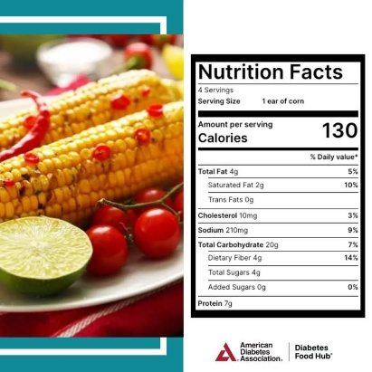

October
World Food Day: October 16, 2026
🍎 🥦 Food is powerful. It can help you manage blood glucose (blood sugar), improve your health, and even prevent complications. This #WorldFoodDay, find delicious recipes and resources to make healthy eating easier at diabetesfoodhub.org.
Suggested Visual:


From heart disease to depression, obesity is linked to over 200 medical conditions. Educate yourself on the risks and start your journey to better health. Discover more from the Obesity Association, a division of the American Diabetes Association® at obesityassociation.org.
Suggested Visual:


November- American Diabetes Month
🚨 Over 40 million Americans are living with diabetes. The American Diabetes Association® is on a mission to end this epidemic. Join us this #AmericanDiabetesMonth by getting involved and spreading awareness. Learn how you can get involved at diabetes.org/ADM. #WeFight 💪

Suggested Visual:
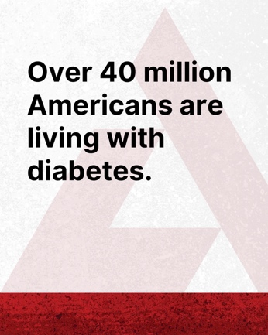

🔍 November is both #AmericanDiabetesMonth and #DiabeticEyeDiseaseMonth—a crucial time to highlight the importance of eye health for those living with diabetes. Regular eye exams can catch issues early and safeguard your vision. 👀 Make your #eyehealth a priority, not just this month, but always. Find helpful eye-related resources from the American Diabetes Association® at diabetes.org/EyeHealth.

Suggested Visual:


World Diabetes Day: November 14, 2026
On #WorldDiabetesDay, let's come together 🤝 to support the 589 million adults with diabetes and educate those at risk. Learn more about how you can show your support at diabetes.org/ADM. 🌍💙 #AmericanDiabetesMonth #WeFight

Suggested Visual:
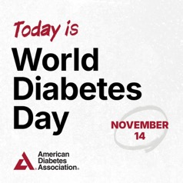

December
Giving Tuesday: December 1, 2026
I fight for a future without diabetes because no family should have to see their loved ones struggle with this disease. That’s why I’m proud to support the American Diabetes Association® this #GivingTuesday. Will you join me in the fight to end diabetes? Donate today at diabetes.org/Donate. 💙 🥊 #WeFight
Suggested Visual:


✨ The holiday season has arrived! Did you know the National Diabetes Prevention Program can help you discover nourishing holiday foods that support your health and provide resources for making informed decisions? 🥦 📚 See if you qualify today at dpp.diabetes.org/DiabetesPrevention. #PreventDiabetes #DiabetesPreventionProgram

Suggested Visual:

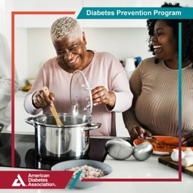

🌟🛫 Don't let diabetes hold you back! Check out travel tips from the American Diabetes Association® and stay safe on the go. Learn more at bit.ly/4f7ER0I. #DiabetesTravelTips #HolidayTravel

Suggested Visual:

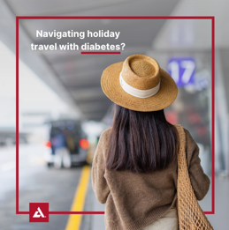

Diabetes is personal for me. Over 155 million Americans are living with diabetes or prediabetes. We're fighting to end this epidemic! 💪 Join me by making a donation at diabetes.org/Donate. Together, #WeFight. 👊

Suggested Visual:

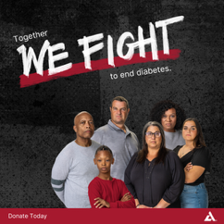

January
Are you one of the many people who look forward to the “January reset” to start or restart a healthy habit? You’re not alone! Check out these tips from the American Diabetes Association® for success and find more information to help you on your journey at bit.ly/3BW1mrz. 🌟💪 #JanuaryReset #HealthyHabits

Suggested Visual:

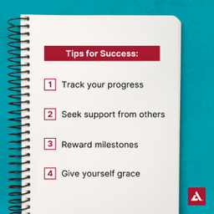

As we navigate the challenges of living with #diabetes, it’s important to remember our mental health is just as crucial as our physical health. 🧠 🚶‍♀️Take the first step today by exploring the American Diabetes Association®’s mental health resources and connecting with a professional who can provide the support you need. Learn more at diabetes.org/MentalHealth.

Suggested Visual:

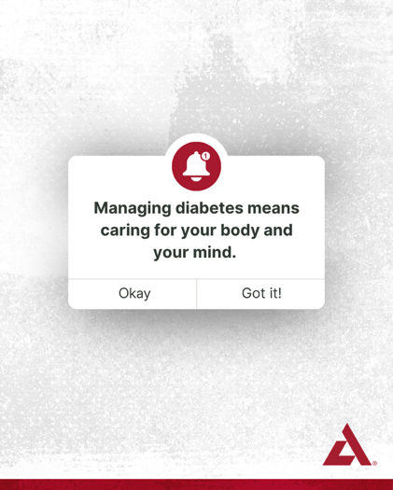

February
#DYK adults with diabetes are twice as likely to have a heart disease or stroke than those without it. Take control this #AmericanHeartMonth! ❤️ Track your blood glucose (blood sugar), blood pressure, and weight. Alert your healthcare team of any changes. For resources and information about the symptoms of heart disease, visit bit.ly/41953EB. #HeartHealth

Suggested Visual:



Super Bowl Sunday: February 14, 2027
Game day alert! 🚨🏈 Need delicious diabetes-friendly appetizers that support your blood glucose (blood sugar)? The American Diabetes Association® has you covered! Check out Diabetes Food Hub® at diabetesfoodhub.org.

Suggested Visual:



#ICYMI: Catch up on the American Diabetes Association®’s Ask the Experts events, focusing on obesity care conversations, available treatments, and more to support your journey. Watch the recordings now at diabetes.org/Experts.

Suggested Visual:
Playlists are at the bottom of diabetes.org/Experts.
March
This #NationalNutritionMonth, make it a priority to discover how nutrition can support your health goals. Learn more from the American Diabetes Association® at bit.ly/3CUvDYo. ✨
Suggested Visual:

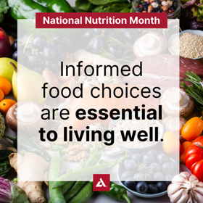

Diabetes is the leading cause of kidney disease. March is #NationalKidneyMonth, a time to shine a light on this vital issue! 🕵️‍♀️ Learn about the link between diabetes and kidney disease and find empowering ways to put your health first at diabetes.org/Kidney.

Suggested Visual:

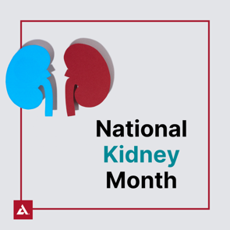

Living with obesity, diabetes, or both can increase your risk for MASLD (metabolic dysfunction-associated steatotic liver disease)—even if you don't have noticeable symptoms.
That's why it's important to understand your risk and take steps to support your liver health.
One place to start? Your plate. The Everyday Essentials Plate provides simple guidance for building balanced meals that can support your health goals. Learn more about eating for liver health at bit.ly/4qR2eTa. #LiverHealth

Suggested Visual:

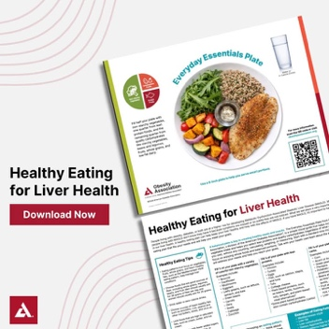

🎉 The 2027 Tour de Cure® season is in full swing with events happening across the country! 🚴‍♂️ 🚴‍♀️ Join us and the American Diabetes Association® at an event near you or learn how you can participate virtually at diabetes.org/Tour. 🌟 #ADATour2027

Suggested Visual:
Or a picture of yourself at a Tour de Cure® event

April
This #NationalMinorityHealthMonth, take action! American Indian/Alaskan Native, non-Hispanic Black, Hispanic, and Asian American adults are at a higher risk for type 2 diabetes. Take the American Diabetes Association®’s free 60-second risk test and share it with your loved ones. Learn your risk now at diabetes.org/RiskTest.
Suggested Visual:

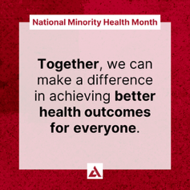

Black Maternal Health Week: April 11-17, 2027
This #BlackMaternalHealthWeek, let’s empower women to prioritize their health during pregnancy. Black women in the U.S. face much higher risks of maternal mortality and complications, especially those living with diabetes. We can make a difference together! Download the American Diabetes Association®’s gestational diabetes (GDM) resources at bit.ly/4292zq0.
Suggested Visual:


National Volunteer Week: April 18-24, 2027
Share your personal story about why you volunteer for the American Diabetes Association® and what it means to you. Be sure to include #NVW and encourage people to join you as a volunteer at diabetes.org/GetInvolved.
For example:
“I started volunteering for the American Diabetes Association® after seeing the impact diabetes had on my loved ones. It's more than just giving time—it's about being part of a community that's determined to make a difference. Every event, every advocacy effort, brings us one step closer to a world free of diabetes. The smiles, the hope, and the resilience I see inspire me to keep going. It's not just about volunteering, it's about being a catalyst for change. That's what it means to me. Want to join me in the fight to end diabetes? Learn more at diabetes.org/GetInvolved.”
Suggested Visual:
A picture of yourself volunteering at an ADA event

National Tell a Story Day: April 27, 2027
Share your story about diabetes, including why you joined the fight to end diabetes, with the American Diabetes Association® and encourage people to share their story too at diabetes.org/ShareYourStory.

For example:
“Living with type 1 diabetes since my late twenties, I've experienced firsthand the daily challenges and triumphs that come with managing this condition. From the initial shock of diagnosis to the endless finger pricks, insulin injections, and constant monitoring, diabetes has been a persistent presence in my life.
I'm not alone in this fight. Each of us has a story to tell—a reason why we want to see an end to this disease. Your story matters and it can inspire others to join us. Please share your personal journey with diabetes at diabetes.org/Blog. Together, with the American Diabetes Association®, we can end diabetes.”
Suggested Visual:
A picture of yourself

May
This #MentalHealthAwarenessMonth, let's not forget that managing diabetes is a journey with both our bodies and minds. Use the American Diabetes Association®’s Mental Health Professional Directory to find a professional near you who can offer the support you need at bit.ly/3E7JGKF. 💪 🧠 ✨
Suggested Visual:
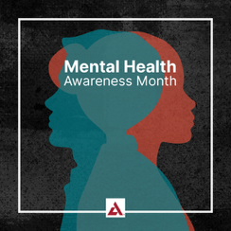
This #HealthyVisionMonth, prioritize your eye health by scheduling a dilated and comprehensive eye exam! 🕶️ 👀 These exams are vital for preventing, detecting, and managing diabetes-related eye disease and vision loss. Discover more tips from the American Diabetes Association® to keep your eyes healthy at diabetes.org/EyeHealthAccess. #EyeHealth #DiabetesAwareness
Suggested Visual:
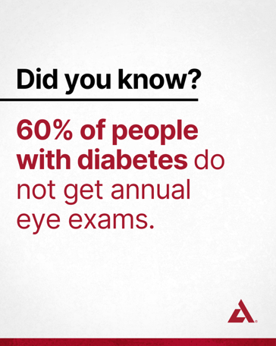

Every year, up to 9% of pregnancies in the United States are affected by gestational diabetes (GDM). This #WomensHealthMonth, I’m standing with the American Diabetes Association® to spread awareness and resources. 💪📚 Learn more about GDM and find additional women’s health resources at bit.ly/3UDfNH2.
Suggested Visual:


You can take action to prevent type 2 diabetes right now. The National Diabetes Prevention lifestyle change program provides education, practical tools and group support to help you build healthier habits. Sign up today and start moving towards a healthier future. Enroll now at dpp.diabetes.org/DiabetesPrevention. #PreventDiabetes #DiabetesPreventionProgram
Suggested Visual:
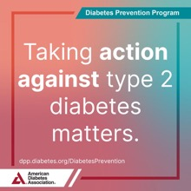

June
June is #MensHealthMonth, a timely reminder that men living with diabetes often face higher risks than women. This is in part because men are less likely to seek care or follow up with their healthcare team. This can lead to diabetes-related complications they’re not aware of, like heart disease, vision loss, and nerve damage, many of which can be avoided with early detection and a treatment plan. For many, the most important step is scheduling the appointment.
Suggested Visual:
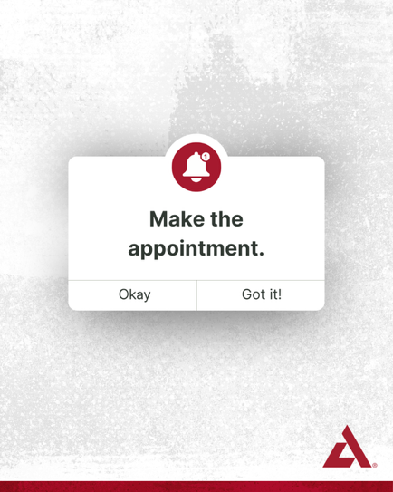

When it comes to diabetic ketoacidosis (DKA), every minute matters!  Recognizing the warning signs, checking ketones early, and knowing what to do next can help you stay safer.

The American Diabetes Association®’s infographic explains when to check ketones, what the results may mean, and when it's time to take action. Learn more and download your copy at bit.ly/45Mw1mF.

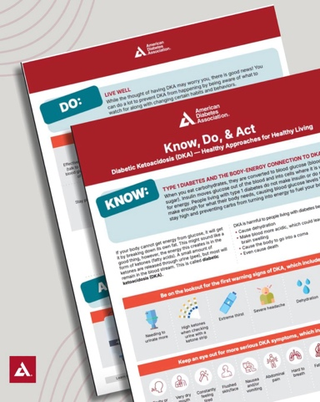

July
Family Meals Month and National Picnic Month are a great reminder that healthy eating doesn't have to be complicated. Simple, balanced meals can help support your health while creating moments that matter.

Find healthy meal inspiration from the American Diabetes Association® at diabetesfoodhub.org.

#FamilyMealsMonth #NationalPicnicMonth



July is National Make a Difference to Children Month! 🎉 The American Diabetes Association® is transforming the lives of countless children with type 1 diabetes every summer through their amazing camp program. 🏕️ Want to learn more? Check out diabetes.org/Camp. #ADACamp2027
Suggested Visual:


👟💙 Step Out® Walk is a chance to raise critical funds to help the American Diabetes Association® fight to end diabetes. Every step and every dollar raised all matter in ending this disease that over 40 million Americans are living with. Find your local walk today at diabetes.org/StepOut. #ADAStepOut2027
Suggested Visual: Or a picture of yourself at a Step Out® Walk event


August
Do you know a child with diabetes? Help them flourish this school year with these must-know tips from the American Diabetes Association®. Explore more resources at diabetes.org/SafeAtSchool. 📚🍎 #SafeAtSchool #BackToSchoolMonth
Suggested Visual:
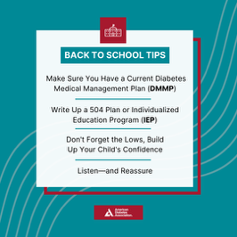
ADA Anniversary: August 27
I'm proud to stand with the American Diabetes Association® in the fight to end diabetes. Will you join me? Discover how you can make a difference at diabetes.org/GetInvolved. 💙 #WeFight
Suggested Visual:
Picture of yourself or reshare National ADA social posts
Individual Rights Day: August 29
This #IndividualRightsDay, take a stand for diabetes awareness and advocacy. Join the American Diabetes Association®’s movement to ensure everyone has access to the care they need as we fight to end diabetes. Become an Advocate today at diabetes.org/BecomeAnAdvocate. 💙 #WeFight
Suggested Visual:


